**PROJECT PLAN**

**PROJECT ESTIMATES**

We are using waterfall model for our project estimation.

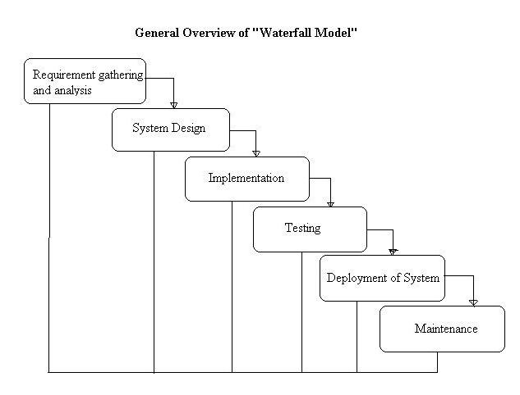

**1. Requirement gathering and analysis:**

In this step of waterfall we identify what are various requirements are need for our project such are software and hardware required, database, and interfaces.

**2. System Design:**

In this system design phase we design the system which is easily understood for end user i.e. user friendly.

We design some UML diagrams and data flow diagram to understand the system flow and system module and sequence of execution.

**3. Implementation:**

In implementation phase of our project we have implemented various module required of successfully getting expected outcome at the different module levels.

With inputs from system design, the system is first developed in small programs called units, which are integrated in the next phase. Each unit is developed and tested for its functionality which is referred to as Unit Testing.

**4. Testing:**

The different test cases are performed to test whether the project module are giving expected outcome in assumed time.

All the units developed in the implementation phase are integrated into a system after testing of each unit. Post integration the entire system is tested for any faults and failures.

**5. Deployment of System:**

Once the functional and nonfunctional testing is done, the product is deployed in the customer environment or released into the market.

**6. Maintenance:**

There are some issues which come up in the client environment. To fix those issues patches are released. Also to enhance the product some better versions are released. Maintenance is done to deliver these changes in the customer environment.

All these phases are cascaded to each other in which progress is seen as flowing steadily downwards like a waterfall through the phases. The next phase is started only after the defined set of goals are achieved for previous phase and it is signed off, so the name "Waterfall Model". In this model phases do not overlap.